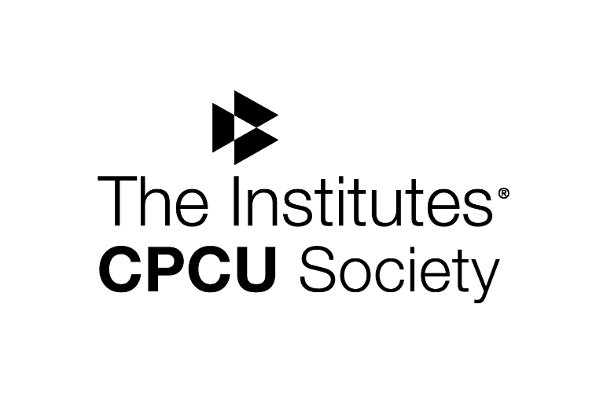
Northeastern NY CPCU Society Chapter

CPCU 530
Business Law for
Insurance Professionals
Class Begins 10/11/17

The Northeastern New York CPCU Chapter is offering classes to prepare students for taking the CPCU 530 exam. The class will run 5 consecutive Wednesday evenings to cover the 10 chapter course as follows:
October 11: Introduction to US Law & Contract Law
October 18: Contract Law – Insurance Applications & Commercial Law
October 25: Property Law & Tort Law
November 1: Agency Law & Insurance Applications of Agency Law
November 8: Business Entities & Employment Law &
The International Legal Environment

Location: 8 Airport Park Blvd. Latham NY 5:30PM – 7:30 PM
Cost: $100 – this includes the class fee only and does not include books or exam fees. To register see page 2.
Study materials are available separately through The Institutes. Please visit their website for additional information on study materials and to learn more about the programs offered: www.theinstitutes.org or call 1-800-644-2101.
Students without employer support: Ask about the NENY CPCU Scholarship Program

Registration for CPCU 530
10/11/17 – 11/8/17

Name: __________________________________
Company: _______________________________
Student Contact Information:
Phone: ___________________
E-Mail: ___________________

To register, please e-mail this completed form to: Melissa.brown@amtrustgroup.com

Please mail your check to: NENY CPCU
PO Box 14793 Albany, NY 12212
Please include a copy of your registration with your check

