Volunteer!

The NENY Chapter of the CPCU Society has scheduled a group volunteer event at the Patroon Land Farm,
a project of the Regional Food Bank of Northeastern New York.

Saturday, October 20 from 9 a.m. to 12 p.m.

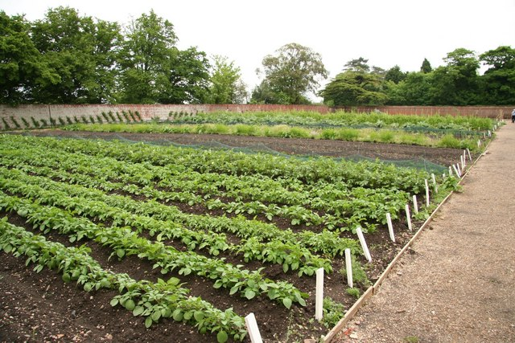
Are you available for a few hours to assist at the farm?

Please see the attached information for details of volunteering at the farm, including clothing requirements and directions to the farm.

Patroon Land Farm
132 Ketcham Rd
Voorheesville, NY 12186

Please respond to Colleen Potten by October 15th
if you are available to attend this volunteer event.
colleen.potten.hk2f@statefarm.com

